Cairo University  
Faculty of Computers and Information



**CS251**

**Software Engineering I**

Project Name

Software Design

Team Names

Month & Year

Contents

Team 3

Document Purpose and Audience 3

System Models 3

I. Class diagrams 3

II. Sequence diagrams 6

Class - Sequence Usage Table 12

Git Repository link 13

# Team

|  |  |  |  |
| --- | --- | --- | --- |
| ID | Name | Email | Mobile |
| 20150332 | Ahmed Amr Ali Al-Akwah | [ahmeditalia122@gmail.com](mailto:ahmeditalia122@gmail.com) | 01144152537 |
| 20150317 | Khaled Mohamed Mohamed | [khaled.elsaka25@stud.fci-cu.edu.eg](mailto:khaled.elsaka25@stud.fci-cu.edu.eg) | 01148827429 |
| 20150331 | Hosam Al-Deen Reda | [hosamelkashb@yahoo.com](mailto:hosamelkashb@yahoo.com) | 01013928223 |
| 20150341 | Mohamed Obada Ayman Fadloun | [Obada.fadloun@gmail.com](mailto:Obada.fadloun@gmail.com) | 01100502981 |
| 20150365 | Mohamed Fadl Al-Hdrmi | [Hdrmim7@gmail.com](mailto:Hdrmim7@gmail.com) | 01126925299 |

# Document Purpose and Audience

* **Purpose of document**
  1. **Describe of the static properties of a system**
  2. **Shows object interactions arranged in time sequence.**
* **-The main users of class diagrams:**

1. **The application domain expert**
2. **The developer**
3. **Designers**

# System Models

## I. Class diagrams

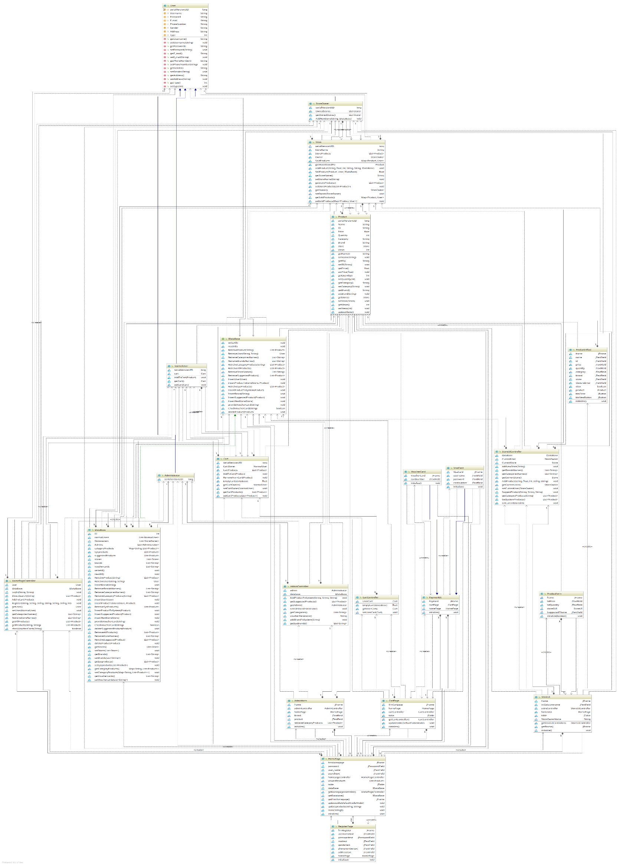

| **Class ID** | **Class Name** | **Description & Responsibility** |
| --- | --- | --- |
| 1 | AdminController | A controller used to control admin actions. |
| 2 | Adminform | Control panel for admin (view). |
| 3 | Administrator | System admin responsible to add product, brand and voucher Card to system |
| 4 | Cart | User bag to store user’s products to purchase it later. |
| 5 | CartController | A controller responsible to control user’s bag |
| 6 | CartPage | A cart view to view user’s cart. |
| 7 | DataBase | Hold everything in the system. |
| 8 | HomePage | Start page to view all products, sign in, register, explore, direct search. |
| 9 | HomePageController | A controller to control the homepage functions. |
| 10 | IDataBase | An interface for the Database class. |
| 11 | NormalUser | The user who the system was made to serve he can explore, direct search, purchase. |
| 12 | PaymentUI | A view user can pick his payment transaction. |
| 13 | Product | Entity. |
| 14 | ProductForm | A view page used to enter product information to add product to store and to suggest a product to system. |
| 15 | ProductInfGui | A view page to show most viewed products. |
| 16 | RegisterPage | A view page used to get user information to add a new user to the system. |
| 17 | Store | An entity for store. |
| 18 | StoreOwner | A user who own a store to sell products. |
| 19 | StoreUI | A view page for stores. |
| 20 | StoreUIController | A controller used to control store ui to add new store, product to store. |
| 21 | User | Entity |
| 22 | VisaCard | View page to take visa information. |
| 23 | VoucherCard | View page to take voucher number. |

## II. Sequence diagrams

1. 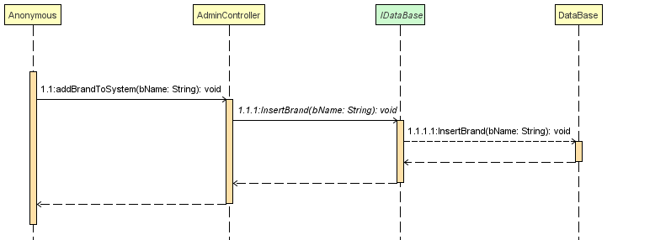Add Brand
2. Add new Store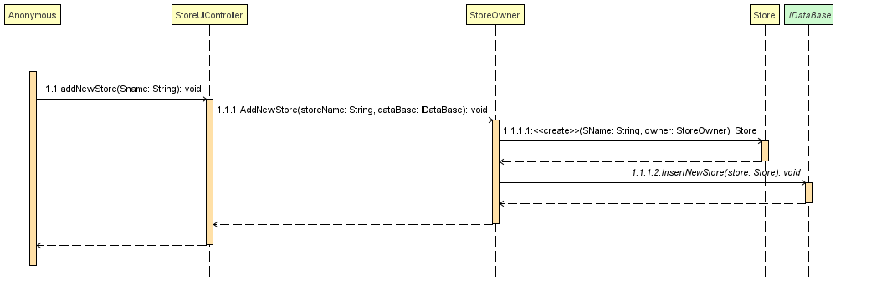
3. Add product to store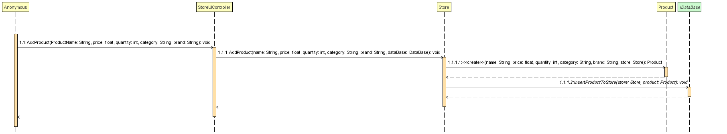
4. Add product to system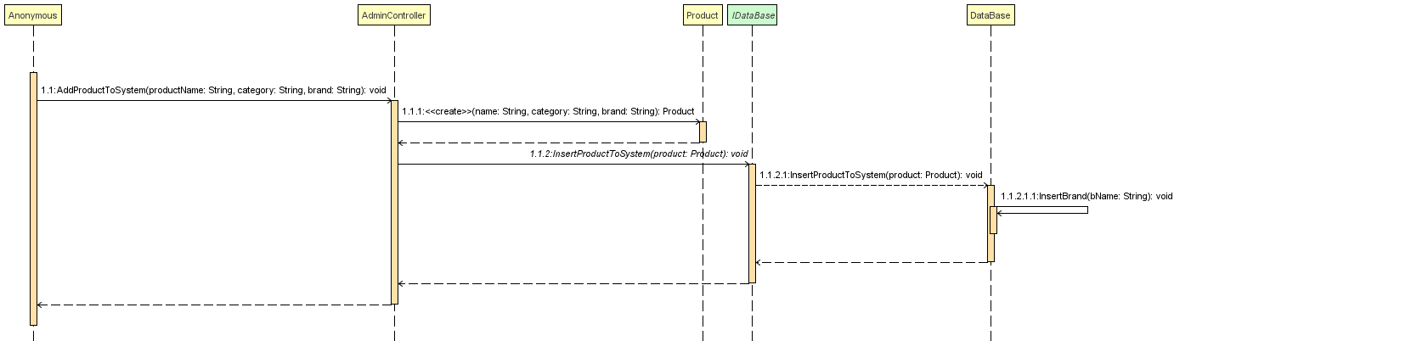
5. Buy product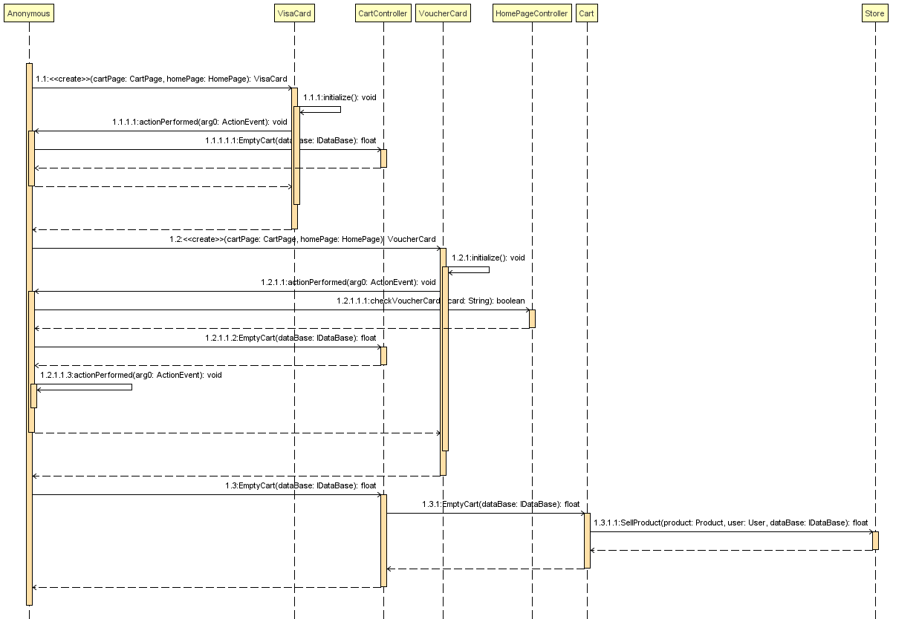
6. Explore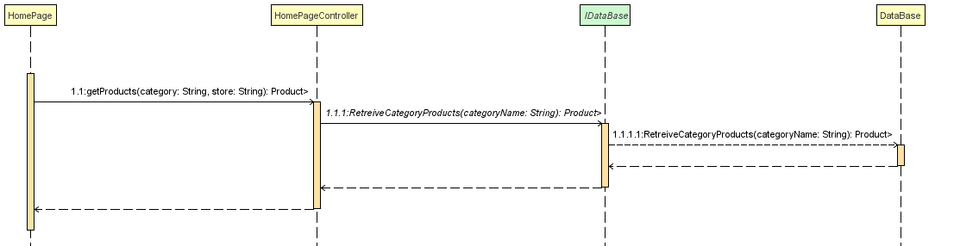
7. Log in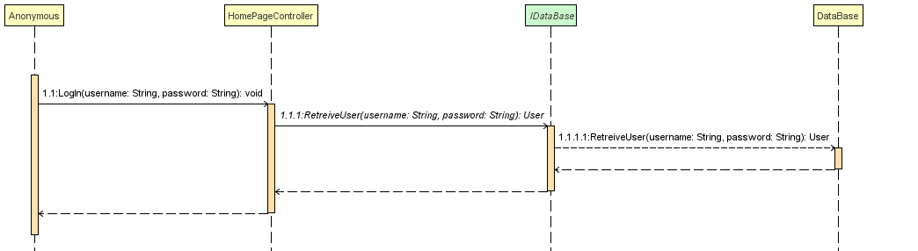
8. Provide voucher card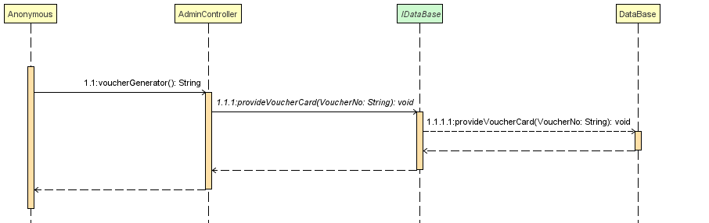
9. Register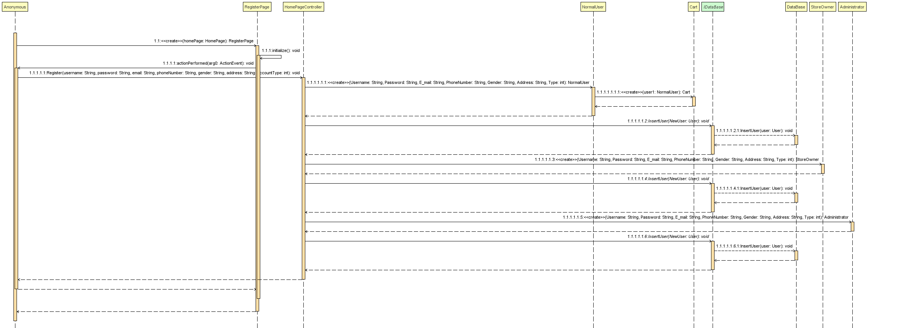
10. Suggest product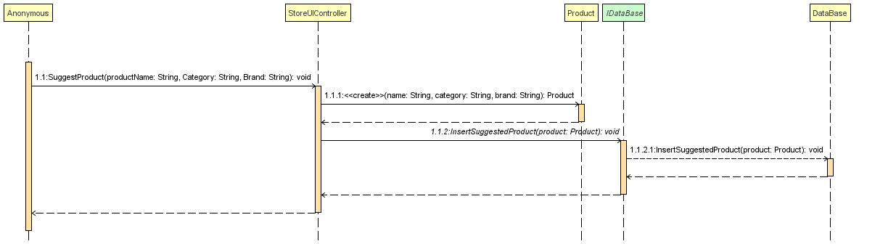
11. 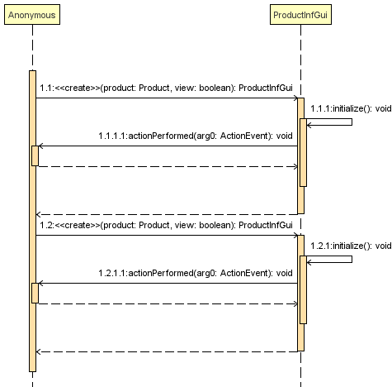View most product

### Class - Sequence Usage Table

| **Class Name** | **Sequence Diagrams** | **Overall used methods** |
| --- | --- | --- |
| AdminController | 1,4,8 | Addbrandtosystem, addproducttosystem, vouchergenerator, |
| Adminform |  |  |
| Administrator |  |  |
| Cart | 5 | Emptycart, |
| CartController | 5 | Emptycart, |
| CartPage |  |  |
| DataBase | 1,4,6,7,8,10 | Insertbrand, insertproducttosystem, retrievecategory, retrieveuser , providevouchercard, insertsuggestedproduct |
| HomePage |  |  |
| HomePageController | 5,6,7,9 | Checkvouchercard, getproducts, login, register |
| IDataBase | 1,2,3,4,6,7,8,10 | Insertbrand, insertnewstore ,insertproducttostore, insertproducttosystem, retrievecategory, retrieveuser, providevouchercard, insertsuggestedproduct |
| NormalUser |  |  |
| PaymentUI |  |  |
| Product | 3,4,10 | Create product, |
| ProductForm |  |  |
| ProductInfGui | 11 | Create productinfgui |
| RegisterPage | 9 | Create registerpage, |
| Store | 2,3,5 | Create new store, addproduct, sellproduct |
| StoreOwner | 2 | Addnewstore |
| StoreUI |  |  |
| StoreUIController | 2,3,10 | Addnewstore, addproduct, suggestproduct |
| User |  |  |
| VisaCard | 5 | Create visacard, |
| VoucherCard | 5 | Create vouchercard, |

## Git Repository link

https://github.com/ahmeditalia/SWEproject